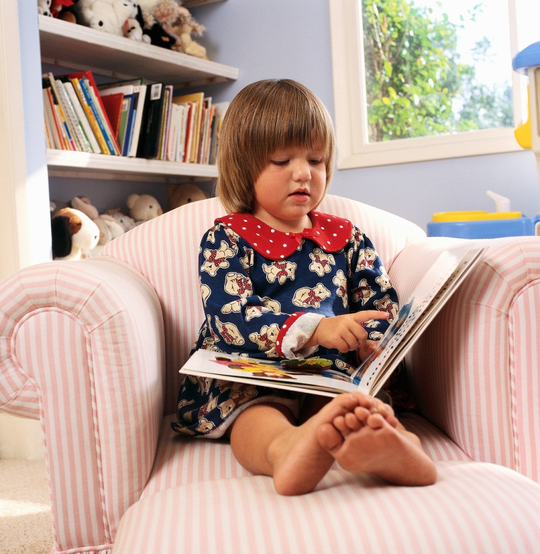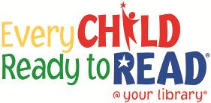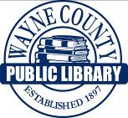

**Your child’s ability to notice print, to understand how to handle a book, and to know how to follow print in a book are part of an early literacy skill that will help them be ready to read.**

**USING BOOKS**

**This project funded in part through an Institute of Museum and Library**

**Services LSTA grant awarded by the State Library of Ohio**

**Print**

**Awareness**