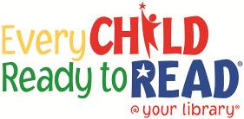

**Phonological**

**Awareness**

**The ability to hear and play with the smaller sounds in words is one of the early literacy skills that researchers say is important for children to have in order to learn to read.**

**SOUNDS**

**This project funded in part through an Institute of Museum and Library**

**Services LSTA grant awarded by the State Library of Ohio**

**This project funded in part through an Institute of Museum and Library**

**Services LSTA grant awarded by the State Library of Ohio**