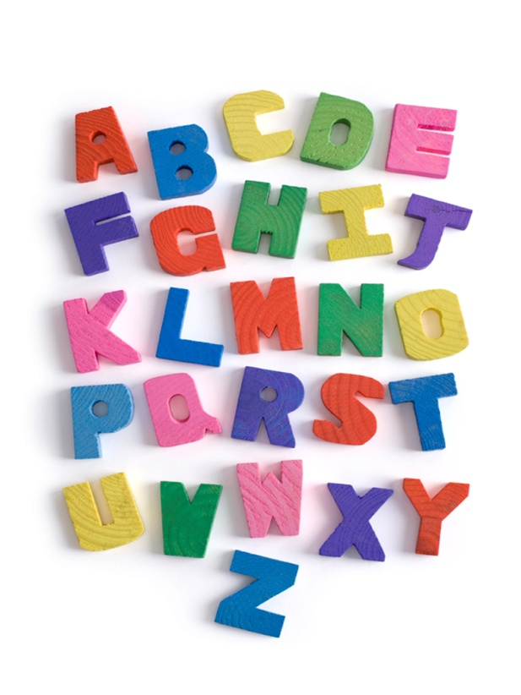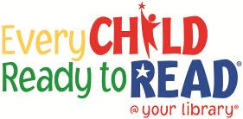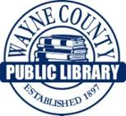

**Learning that letters are different from each other and that they have different names and sounds are part of one of the early literacy skills that researchers say is important for children to grasp in order to learn to read.**

**ABCs**

**Letter Knowledge**

**This project funded in part through an Institute of Museum and Library**

**Services LSTA grant awarded by the State Library of Ohio**