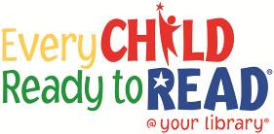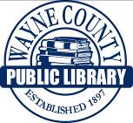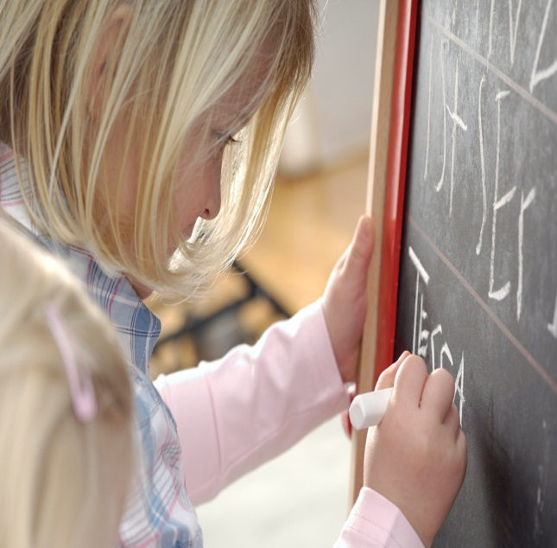

**This project funded in part through an Institute of Museum and Library**

**Services LSTA grant awarded by the State Library of Ohio**

**Vocabulary**

**WORDS**

**Knowing the names of things and learning new words are part of an important early literacy skill for children to achieve when getting ready to learn to read.**